Software Design Approaches - Modular

📖 Definition
# Source: AI Source: Provided by: [Data Path: Persons Table -> ID Column: 1, Name_En Column: Motasem Essam] -> From: [ChatGPT] on [1/23/2026]
The Modular Design Approach is a software design method where a system is divided into smaller, independent modules, each responsible for a specific functionality.
👉 In simple terms:
“Break the system into independent pieces, each doing one job well.”

⚙️ How It Works
# Source: AI Source: Provided by: [Data Path: Persons Table -> ID Column: 1, Name_En Column: Motasem Essam] -> From: [ChatGPT] on [1/23/2026]
- Divide the system into separate modules
- Assign each module a specific responsibility
- Define clear interfaces between modules
- Develop and test modules independently
- Integrate modules to form the complete system

🧩 Key Characteristics
# Source: AI Source: Provided by: [Data Path: Persons Table -> ID Column: 1, Name_En Column: Motasem Essam] -> From: [ChatGPT] on [1/23/2026]
- High Cohesion → Each module focuses on one task
- Low Coupling → Modules are independent of each other
- Encapsulation → Internal details of modules are hidden
- Reusability → Modules can be reused in other systems

✅ Advantages
# Source: AI Source: Provided by: [Data Path: Persons Table -> ID Column: 1, Name_En Column: Motasem Essam] -> From: [ChatGPT] on [1/23/2026]
- Easy maintenance: Changes in one module don’t affect others
- Improved readability: Clear structure and organization
- Reusability: Modules can be reused across projects
- Parallel development: Teams can work on different modules simultaneously
- Scalability: Easy to expand the system

⚠️ Disadvantages
# Source: AI Source: Provided by: [Data Path: Persons Table -> ID Column: 1, Name_En Column: Motasem Essam] -> From: [ChatGPT] on [1/23/2026]
- Design complexity: Requires careful planning of modules and interfaces
- Integration effort: Combining modules can be challenging
- Over-modularization: Too many small modules can increase complexity

🎯 Use Cases
# Source: AI Source: Provided by: [Data Path: Persons Table -> ID Column: 1, Name_En Column: Motasem Essam] -> From: [ChatGPT] on [1/23/2026]
- Large-scale software systems
- Enterprise applications
- Systems requiring frequent updates and maintenance
- Projects developed by multiple teams

🛠️ Simple Example
# Source: AI Source: Provided by: [Data Path: Persons Table -> ID Column: 1, Name_En Column: Motasem Essam] -> From: [ChatGPT] on [1/23/2026]
Problem: Build an Online Shopping System
Modules:
- User Management Module
- Product Catalog Module
- Shopping Cart Module
- Payment Module
- Order Management Module
👉 Each module:
- Works independently
- Can be updated without affecting others

🔄 Modular Design vs Other Approaches (Quick Insight)
# Source: AI Source: Provided by: [Data Path: Persons Table -> ID Column: 1, Name_En Column: Motasem Essam] -> From: [ChatGPT] on [1/23/2026]
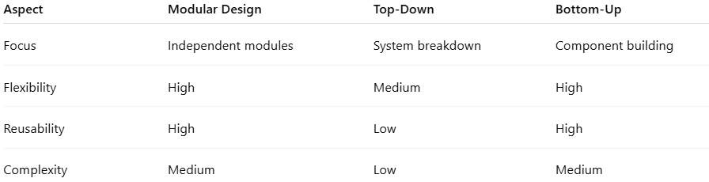
Aspect | Modular Design | Top-Down | Bottom-Up
Focus | Independent modules | System breakdown | Component building
Flexibility | High | Medium | High
Reusability | High | Low | High
Complexity | Medium | Low | Medium

📌 Summary
# Source: AI Source: Provided by: [Data Path: Persons Table -> ID Column: 1, Name_En Column: Motasem Essam] -> From: [ChatGPT] on [1/23/2026]
The Modular Design Approach structures software into independent, reusable modules with clear responsibilities. It improves maintainability, scalability, and team collaboration, making it ideal for large and complex systems. However, it requires careful planning to avoid integration challenges and excessive complexity.

